1. High Level Test Plan

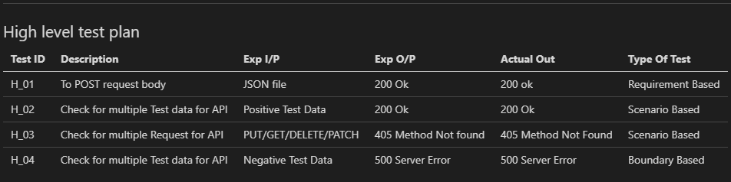

1. Low Level Test Plan

